# **A screenshot of a video game Description automatically generatedRepo name: hogwarts_studentlist**

**REPO LINK:** <https://github.com/mort108v/hogwarts_studentlist>

**SITE LINK:** <https://mort108v.github.io/hogwarts_studentlist/>

# **HOW TO HACK THE SYSTEM**

1. **HOVER OVER THE ALMOST TRANSPARENT ANONYMOUS MASK IN THE TOP LEFT CORNER OF PAGE**
2. **DOUBLECLICK THE MASK**
3. **HIT THE >>CTRL<< BUTTON ON YOUR KEYBOARD**

# **SITE FEATURES**

**IMPORT STUDENT INFO AND BLOODSTATUS FROM JSON**

**CLEANUP DATA AND INJECT TO AUTOGENERATED LIST**

**SORT STUDENTS ASCENDING/DESCENDING - BY FIRST, MIDDLE, LAST, NICKNAME, HOUSE, BLOODSTATUS, PREFECT AND INQUISITORIAL SQUAD**

**FILTER STUDENTS BY ALL STUDENTS, PREFECTS, INQUISITORIAL SQUAD, PUREBLOODS, HALFBLOODS AND EXPELLED**

**DISPLAY POPUP WITH IMAGE, FIRSTNAME, HOUSE, GENDER, IS PREFECT, IS INQUISITORIAL SQUAD AND BUTTONS FOR MAKE/REMOVE PREFECT, MAKE/REMOVE INQUISITORIAL SQUAD AND EXPELL STUDENT**

**AUTOGENERATED NUMBERS LIST FIXED TOP RIGHT CORNER**

**ABILLITY TO TOGGLE PREFECT AND INQUISITORIAL SQUAD FROM LIST AND RESTRICTION ON MAX 2 PREFECTS AND ONLY PUREBLOODS AND SLYTHERING STUDENTS CAN BE ELECTED INQUISITORIAL SQUAD WITH DIALOG WARNING AND ABILLITY TO CHOOSE WHICH TO REMOVE TO APPOINT MORE – NAMES IN DIALOG ARE AUTO GENERATED FROM CLICKED**

**SEARCHBAR THAT AUTOGENERATES STUDENT LIST FROM FIRST AND LASTNAME UPON CHARACTER INPUT**

**HOVERCHANGE ON INDIVIDUALY GENERATED STUDENTS FIRSTNAME**

**CUSTOM SCROLLBAR WITH COLORCHANGE ON HOVER**

**HACKING THE SYSTEM**

**ACTIVATED BY DOUBLE CLICK + KEYBOARD ACTION  
 TITLE TEXT IS REPLACED WITH TYPEWRITTEN MESSAGE WITH MATCHING SOUNDS  
 RANDOM COLORING OF STUDENTLIST TABLE IS IMPLEMENTED ON EACH LIST REBUILD  
 ALL HALFBLOODS ARE MADE PUREBLOODS  
 RANDOM MATH NUMBER OF PUREBLOODS ARE MADE HALFBLOODS  
 INJECTING SELF TO ALLSTUDENTS LIST AND MADE PREFECT  
STUDENTS (INCLUDING SELF) CANNOT BE EXPELLED WITH DIALOG WARNING WITH AUTOGENERATED NAME OF STUDENT**

**SYSTEM CANNOT BE HACKED TWICE WITH ALERT**

**SORTING AND FILTERING REMEMBERS HACKED**

# **WORKFLOW DOCUMENTATION**

**WIREFRAME**



**PSEUDO, ACTUAL CODE AND FLOWCHART/DIAGRAM**



**PREPERATION**

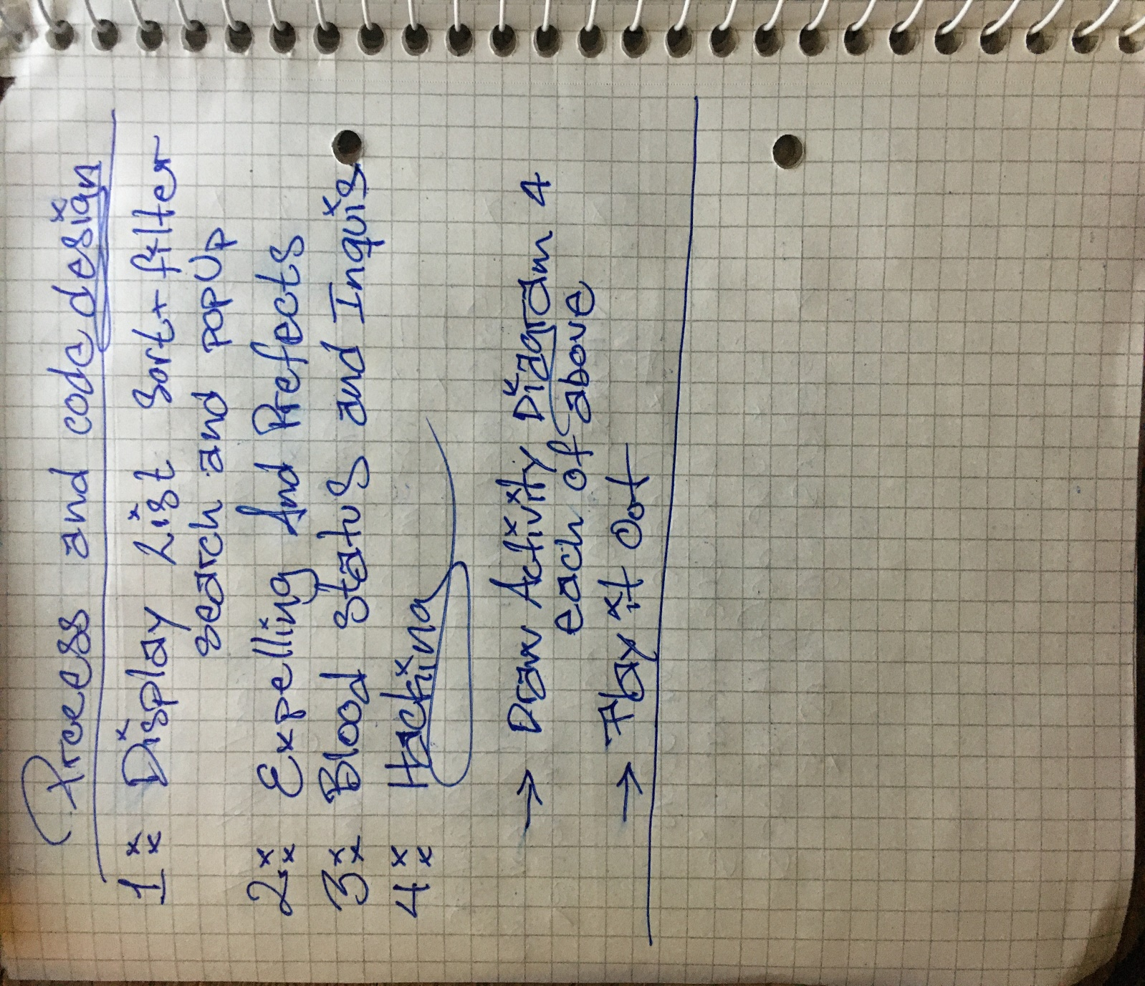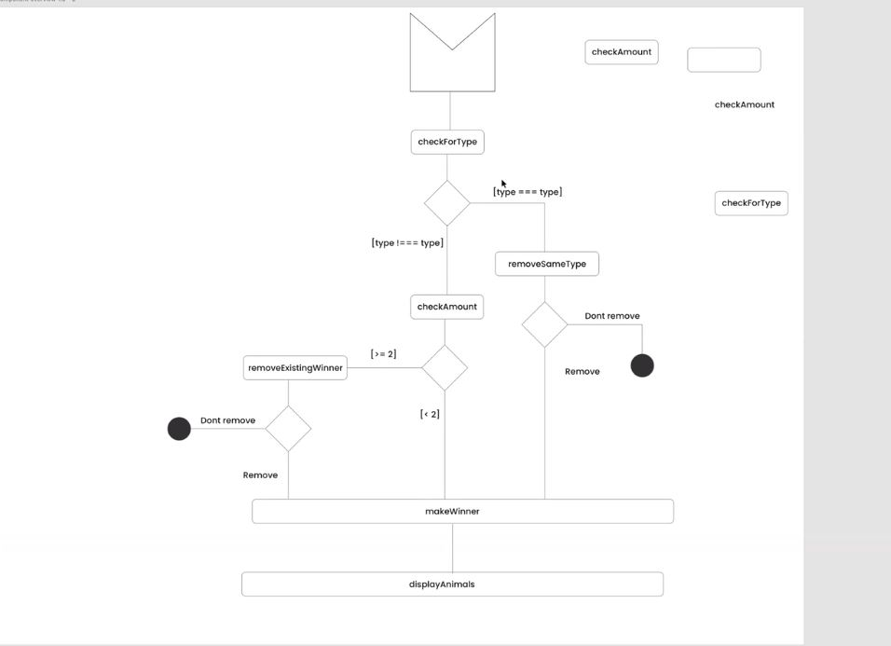

# **SCREEN GRABS**

**ANONYMOUS MASK TO HACK THE SYSTEM**

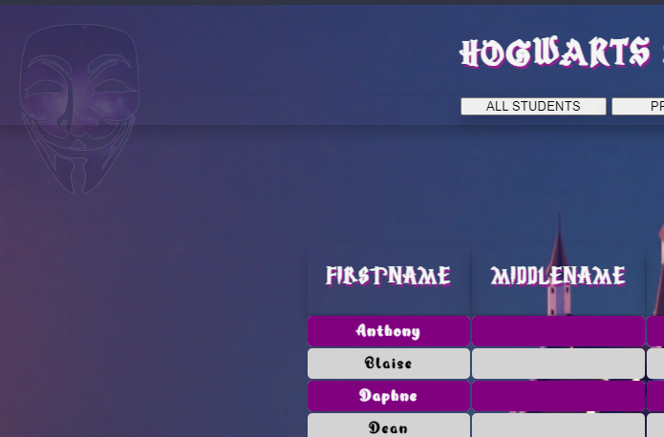

**TYPEWRITER AND COLOR ACTION ON HACKED**

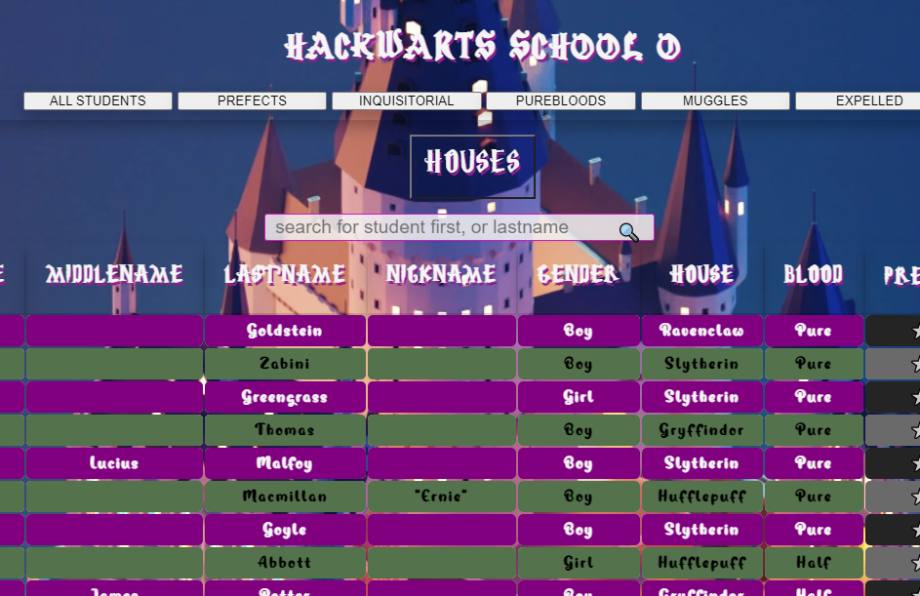

**DIALOG BOX ON MAKING SOMEONE INQUISITORIAL ERROR**

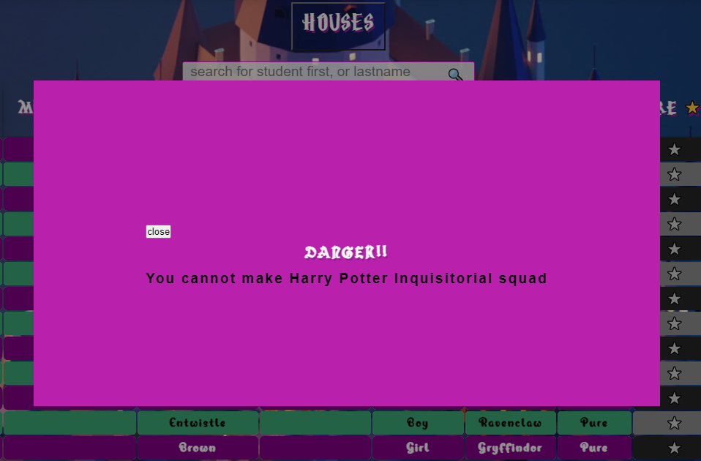

**DIALOG BOX FOR REMOVING PREFECT WHEN TRYING TO APPOINT > 2**

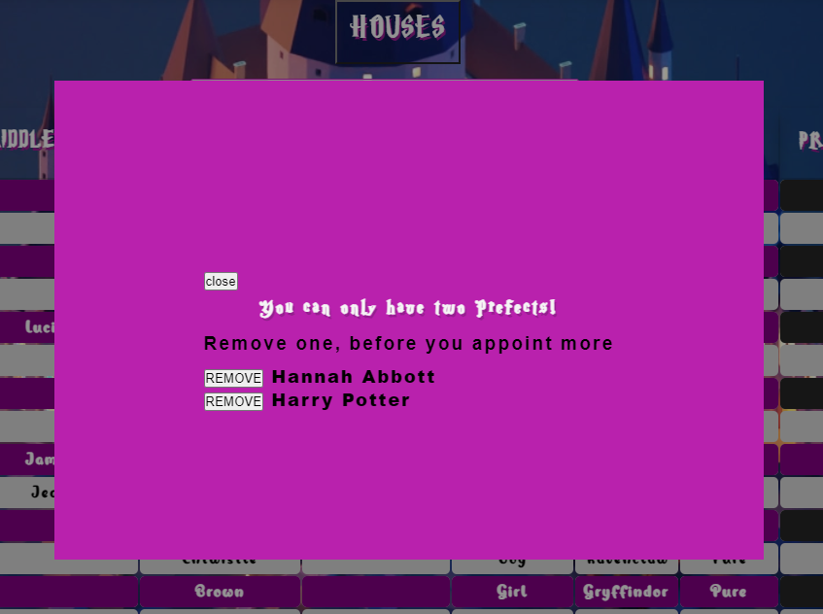

**SEARCHBAR NON-CASE SENSITIVE FOR FIRST AND LAST NAME**

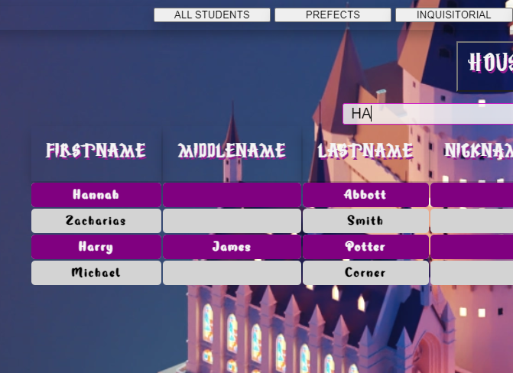

**DROPDOWN MENU FOR FILTERING BY HOUSE**

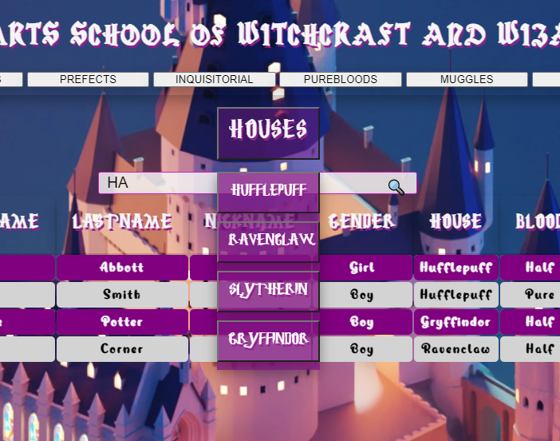

**CUSTOM SCROLLBAR WITH COLORCHANGE ON HOVER**

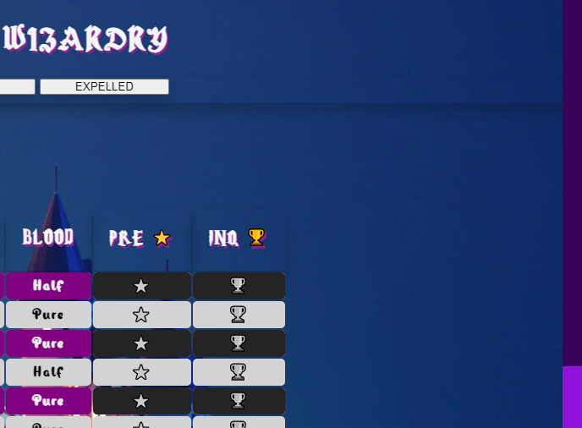

**TOGGLE PREFECT AND INQUISITORIAL SQUAD FROM LIST**

